# Spectral Tools

## Purpose

This module offers a set of functions for handling spectral data. These functions are:

* Spectrum extraction; this allows the user extract an aggregated spectral profile with a used specified kernel size.

## Installation

Install the .sav files in the save_add folder (see also [ENVI .sav files: Installation and configuration](http://www.itc.nl/personal/nieuwenh/installations.html).

_nrsmenu.sav Define NRS menu item in ENVI

nrs_Utils.sav Library with utility routines

nrs_Spectral_tools.sav The actual software

## Usage (gui)

|  |  |
| --- | --- |
| nrs_aggregate_spectrum_gui | Start the user interface of the spectrum extraction. |

Alternatively the commands can be started from the ENVI menu: ‘NRS | Spectral Tools’:

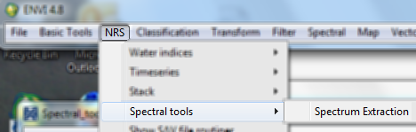

### Spectrum Extraction

Menu option is ‘NRS | Spectral Tools | Spectrum Extraction, the command line is ‘nrs_aggregate_spectrum_gui’. This function reads the coordinates of point features from either a text table or a shape file to get spectral profiles from a spectral image. It uses a square window around the locations in the spectral image, collects the spectra of all these location and applies an aggregation function to these profiles.

The resulting profiles for all locations are then written to a text table. The header line of each column contains the coordinates of that location.

The user interface is shown below:

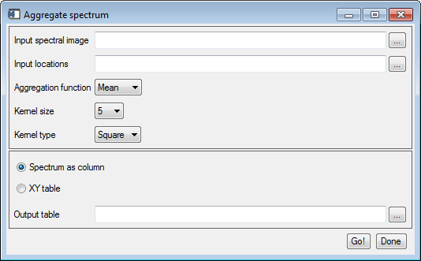

Explanation of all the fields:

|  |  |
| --- | --- |
| Input spectral image | Select an spectral input image |
| Input locations | Select a point feature table; this can either be a comma-delimited file (*.csv) or a shape file. In case of a text table file: the file must contain a header line indicating the coordinate columns; the coordinate columns are recognized by the texts *lat*, *lon* or *x* and *y*. |
| Aggregation function | Select the aggregation function. The GUI supports *mean*, *median*, *min* and *max*. The default is *mean*. |
| Kernel size | The size of the window. Supported are 1 (single spectrum), 3 (3 x 3), 5, 7, 9, 1 |
| Kernel type | Specify the area to sample the spectra. Possible are **square**, and **circle**. The sampling assumes equal size pixels. |
| Spectrum as column | Save the output table with one spectrum per column (field); the header line contains the coordinate pair of the location |
| XY table | Save the output table with one location and spectrum per row (record). This type of table is easier to import into GIS software as features. |
| Output table | The filename of the output profile table. |

An example of the input point table (in csv format); note that extra columns are allowed, here the pixel coordinates are added as well:

lat,lon,px,py

33.70480278,107.8058417,57,12

33.55983889,107.8718278,83,79

33.63168611,107.6789417,7,47

Examples of the output table (shortened):

With the option *Spectrum as column*:

(31.335300:-22.759450),(31.324700:-22.761067),(31.324833:-22.761683)

400.680,400.920,506.560

…

420.600,450.600,544.320

2089.28,2022.96,1982.36

1580.40,1554.16,1664.60

912.480,975.960,1104.48

949.920,1009.32,1132.96

879.680,940.840,1059.00

726.400,804.240,911.800

590.320,674.000,763.280

…

With the option *XY table*:

X,Y,band_1,band_2,band_3

31.33530000000000,-22.75945000000000,400.6799926757813,420.6000061035156,2089.280029296875

31.32470000000000,-22.76106700000000,400.9200134277344,450.6000061035156,2022.959960937500

31.32483300000000,-22.76168300000000,506.5599975585938,544.3200073242188,1982.359985351563

31.32391700000000,-22.76123300000000,505.0400085449219,579.8800048828125,2060.439941406250

31.32390000000000,-22.76180000000000,509.9200134277344,550.7199707031250,2099.800048828125

31.31465000000000,-22.76345000000000,468.5599975585938,549.3599853515625,1905.239990234375

31.31421700000000,-22.76266700000000,465.4800109863281,530.2000122070313,1856.599975585938

31.30395000000000,-22.76573300000000,480.4800109863281,532.5200195312500,1951.880004882813

31.30351700000000,-22.76591700000000,495.5599975585938,473.2399902343750,2198.159912109375